Report of internship in DataScience, AI&ML

# At

# Sprout Knowledge Solutions Pvt. Ltd.

# 

# 11.07.2022 to 11.08.2022

## 

## Submitted by:

## Student Name

R.BHUVANESHWARAN

S.SATHIYA

V.VIKRAM

# 

# Department

COMPUTER SCIENCE ENGINEERING(M.TECH)

&

ARTIFICIAL INTELLIGENCE AND DATA SCIENCE(B.TECH)

## College

ERODE SENGUNTHAR ENGINEERING COLLEGE

## 

# Table of contents

* Acknowledgement
* Information about the company
* Information about the internship
* Description of internship experience
* Project Work
* Conclusion

# 

# Acknowledgement

I undertook this internship project and completed the internship report under the guidance of Mr SENTHIL VELAVAN, Head of Department (CSE) and Mr Narendiranath Academy head of Sprout Knowledge Solutions Pvt. Ltd. I'm grateful to the Sprout Knowledge solutions Pvt. Ltd. staff for their patience and assistance during my training at their company. It was a good learning experience for me to work with them, as the project involved real-time scenarios and got an idea of how to deal with real-time projects.

# 

# Information about the company

An EdTech Firm that provides Upskilling Courses for Students in Software Coding & Development Programmes across India & various other countries like Australia, the United States, France, Saudi Arabia & Far East. With our Global Experience very soon we are stepping into 11 countries of the African continent.

We Develop our proprietary content that suits the current & future trends, which will help the student community navigate the ever changing future. Sprout's Courses are designed to achieve the following for the students - Future Ready, Develop Problem Solving Skills, Enhance Collaboration & Creativity, and Develop Communication.

We aim to create engaging and enriching learning experiences that empower the next generation of computer coders, developers, and makers of the future. Our Industry ready courses with 100% Hands-on methodology and our 4C approach (Critical thinking, Creativity, Collaboration and Communication) make us unique in the tech market. We are also working with DataScience projects for our clients, which makes us unique in this domain.

# 

# 

# 

# Description of the internship experience

First of all I want to thank you for giving me such a great learning experience about this course. It was such a good experience for me. Now I got an idea about this course and I am able to solve the programs related to this. You are providing such wonderful learning for our youngsters. Your way of teaching is very good and we can understand the complicated problems.

The problems and projects mentors give to us are very useful for me.From that we will be able to gain more knowledge about this course.I am very eager to learn more about this course.

## 

***Student’s experience with the internship***

Being an intern at sprout knowledge solution was too great.

We haven’t know about the artificial intelligence and the machine learning in depth.The simple and clear explanation by the mentor and his calmness that he had explaining the concepts and other stuff made us to get really into the world of data science and machine learning concepts.we learn many new skills and learn how to apply in real time projects,how to collect data analysis,the data using pandas,matplotlib and how to use AL and ML algorithms.

It’s so helpful and also to solve the client requirements.The real time projects that are provided by sprout were really made us think to solve the requirements.Finally the experience in sprout is great!. This experience has gotten us more excited to learn new things in future.

We are more thankful to our mentor Mr.NARENDHIRANATH now we understand the actual life cycle of data science.

## 

## 

## The tasks I undertook included:

1. DataScience Project Lifecycle
2. How to interact with clients and project manager
3. How to identify client requirements
4. Data Collection
5. Data Analysis using Python libraries such as NumPy, Pandas, Matplotlib, Seaborn
6. AI and ML algorithm using Python library Scikit Learn
7. Realtime projects
8. How to document client requirements
9. Creating Insights and presenting them to the project manager as well as the client

### 

### 

### 

### 

### 

### 

### 

### 

### ***Project work (based on the project given)***

**Title: Mark Prediction**

**Problem Statement:**

Mr Karthik is working on a new platform for their college student management system. Now he wants to add a new feature in that application. Based on the student's internal marks, that feature will predict

how many marks the student can score in the semester examination. Use the previous data set and train the model.

Data Set: Use your previous semester result of CIA I, CIA 2, CIA 3 and your semester result in numbers.

**Process:** Data Science LifeCycle

**Understanding the Business and Client requirement:**

**Data Collection**

[**https://drive.google.com/file/d/1zoozSGG5ObfDiMiicu7O9joKPGevgXJ6/view?usp=sharing**](https://drive.google.com/file/d/1zoozSGG5ObfDiMiicu7O9joKPGevgXJ6/view?usp=sharing)

**Data Analysis**

[**https://drive.google.com/file/d/1UWFVD4KcFcOU57Eu7ZeSzGqiGccyYjQR/view?usp=sharing**](https://drive.google.com/file/d/1UWFVD4KcFcOU57Eu7ZeSzGqiGccyYjQR/view?usp=sharing)

[**https://drive.google.com/file/d/1yuR-KYBNNl_lS8a7vmW4_lIsKQ4F9Bk3/view?usp=sharing**](https://drive.google.com/file/d/1yuR-KYBNNl_lS8a7vmW4_lIsKQ4F9Bk3/view?usp=sharing)

**ML Model**

[**https://drive.google.com/file/d/1g3PI-w3P5PqlRhQ_chJlkNoGVDCHSSa3/view?usp=sharing**](https://drive.google.com/file/d/1g3PI-w3P5PqlRhQ_chJlkNoGVDCHSSa3/view?usp=sharing)

**Insight (Final Output)**

[**https://drive.google.com/file/d/1ydIH0ms1hej4hPtwZl8S0hfE4wYLpKkq/view?usp=sharing**](https://drive.google.com/file/d/1ydIH0ms1hej4hPtwZl8S0hfE4wYLpKkq/view?usp=sharing)

**Data set:**

[**https://drive.google.com/file/d/1zoozSGG5ObfDiMiicu7O9joKPGevgXJ6/view?usp=sharing**](https://drive.google.com/file/d/1zoozSGG5ObfDiMiicu7O9joKPGevgXJ6/view?usp=sharing)

**Input files:**

[**https://drive.google.com/file/d/1OA-kLsuOfzPaX0Am_HDjuHtVNLbyXCnC/view?usp=sharing**](https://drive.google.com/file/d/1OA-kLsuOfzPaX0Am_HDjuHtVNLbyXCnC/view?usp=sharing)

**Output files:**

[**https://drive.google.com/file/d/1ydIH0ms1hej4hPtwZl8S0hfE4wYLpKkq/view?usp=sharing**](https://drive.google.com/file/d/1ydIH0ms1hej4hPtwZl8S0hfE4wYLpKkq/view?usp=sharing)

**Source code:**

[**https://drive.google.com/file/d/1UWFVD4KcFcOU57Eu7ZeSzGqiGccyYjQR/view?usp=sharing**](https://drive.google.com/file/d/1UWFVD4KcFcOU57Eu7ZeSzGqiGccyYjQR/view?usp=sharing)

[**https://drive.google.com/file/d/1yuR-KYBNNl_lS8a7vmW4_lIsKQ4F9Bk3/view?usp=sharing**](https://drive.google.com/file/d/1yuR-KYBNNl_lS8a7vmW4_lIsKQ4F9Bk3/view?usp=sharing)

**Screenshot:**

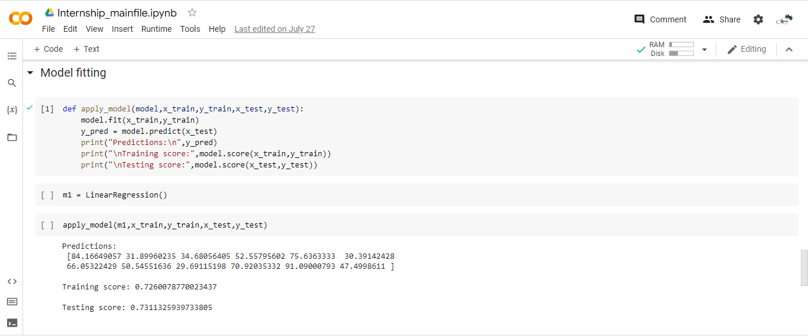

**Sample output:**

[**https://drive.google.com/file/d/1ydIH0ms1hej4hPtwZl8S0hfE4wYLpKkq/view?usp=sharing**](https://drive.google.com/file/d/1ydIH0ms1hej4hPtwZl8S0hfE4wYLpKkq/view?usp=sharing)

**Project Explanation:**

**The data was taken from our previous semester marks for real world analysis.**

**After the necessary preprocessing,the linear regression model was applied with default parameters which produced a testing accuracy of 73% which seems to be reasonable considering the small dataset.**

**The model was exported with pickle and then used to predict the current semester marks.**

**Overall the prediction model was satisfactory for the given dataset.**

# 

# 

# 

# 

# 

# 

# 

# 

# 

# 

# 

# Conclusion

From my Internship at Sprout Knowledge Solutions Pvt. Ltd. I was able to understand the actual workflow of how Data Science projects will look like and had hands-on experience with some projects. However, I need to learn a lot in this domain to excel.

Overall I got Hands-on experience in DataScience, AI and ML.

Submit your projects: [narain2829@gmail.com](mailto:narai2829@gmail.com)